PROG2002 – Web Development II
Assignment 2: Use Case (A Dynamic Website)

Student ID: 24832054 Last Name: Chengyu First Name: Gao

Title of the project:
Charity Events Hub - A Dynamic Website for Community Charity Events
Introduction/Motivation
Charity events are often scattered across social media, flyers, and emails, which makes it difficult for the public to discover and support local causes. This project aims to bridge the gap between charitable organisations and potential attendees by providing a centralized, user-friendly platform. By making event details, ticket prices, and fundraising progress easily accessible, the website encourages greater community participation and awareness.
Problem Statement
Currently, there is no unified platform for searching and managing charity events by specific criteria such as date, location, and category. Potential attendees struggle to find relevant events, and there is a lack of transparency regarding fundraising goals and progress. Additionally, event organizers need a way to manage event visibility, which is difficult without a dynamic database system.
Solution
I developed a fully dynamic website using a client-server architecture. The backend uses Node.js and Express to serve data via RESTful APIs from a MySQL database. The frontend is built entirely with vanilla HTML, CSS, and JavaScript. It communicates with the server using the asynchronous fetch API, with data exchanged in JSON format. The backend handles data retrieval and security using parameterized queries, while the frontend dynamically renders the UI using native DOM manipulation.
Web UX
My main priority was an intuitive and modern user experience while strictly adhering to the constraint of using no frontend frameworks.
- Navigation: A consistent navigation bar is present on all pages.
- Home Page: Uses CSS Grid and Flexbox for responsive event cards, featuring category badges and dynamic progress bars.
- Search Page: Uses appropriate HTML5 input controls (date picker, text field, dropdown). A "Clear Filters" button is implemented using pure DOM manipulation to reset all fields without reloading.
- Event Details: Displays a "Goal vs. Progress" bar and a "Register" button that triggers an interactive modal alert.
Data Schema
The MySQL database (charityevents_db) consists of three relational tables:
- organisations: Stores charity organization details.
- categories: Stores event categories (e.g., Fun Run).
- events: The core table storing event details, linked to organisations and categories via Foreign Keys (org_id, category_id).
The events table includes a status column (ENUM: 'upcoming', 'past', 'suspended'), allowing the system to automatically filter out past events and hide suspended ones from the home page.
The database schema and sample data were exported from MySQL Workbench into a single charityevents_db.sql script, which is included in the repository so the database can be recreated locally.
API design
I implemented four RESTful API endpoints using Node.js and Express. All endpoints use the GET method, as they are strictly read-only operations, making them safe and idempotent.
GET /api/events - Homepage: Retrieves all upcoming events.
GET /api/events/search - Search: Accepts query parameters (date, location, categoryId) to filter dynamically.
GET /api/categories - Populates the search dropdown.
GET /api/events/:id - Detail: Retrieves a single event's complete information.

Example endpoint: GET /api/events/search
Purpose: This endpoint lets users discover active charity events by combining up to three optional filters (date, location and category). It powers the Search Events page.
Request: As a GET request it has no request body. Filters are sent as URL query parameters, for example: /api/events/search?date=2026-11-15&location=Park&categoryId=1
Response: A JSON array of matching events. Each event object contains event_id, title, description, event_date (formatted as YYYY-MM-DD to avoid timezone issues), location, ticket_price, goal_amount, current_amount, category_name and status. If no filters match, an empty array is returned and the client shows a "No events found" message.
Security & Date Fix: I used pool.execute with ? placeholders (parameterized queries) to prevent SQL injection. Furthermore, I applied SQL's DATE_FORMAT function to return clean YYYY-MM-DD strings, avoiding timezone conversion issues between the database and the browser.
Gen AI acknowledgement and Chat Log
- I acknowledge that I have used GenAI tools to complete this assessment.
I used Deepseek to assist with code debugging, syntax checking, and translating/paraphrasing my own written ideas within the parameters outlined in the Assessment Brief and by the Unit Assessor. Below are screenshots of my chat log to demonstrate that AI was used to further my understanding and improve clarity, rather than generating the final code directly.

Figure 1: Debugging the timezone bug

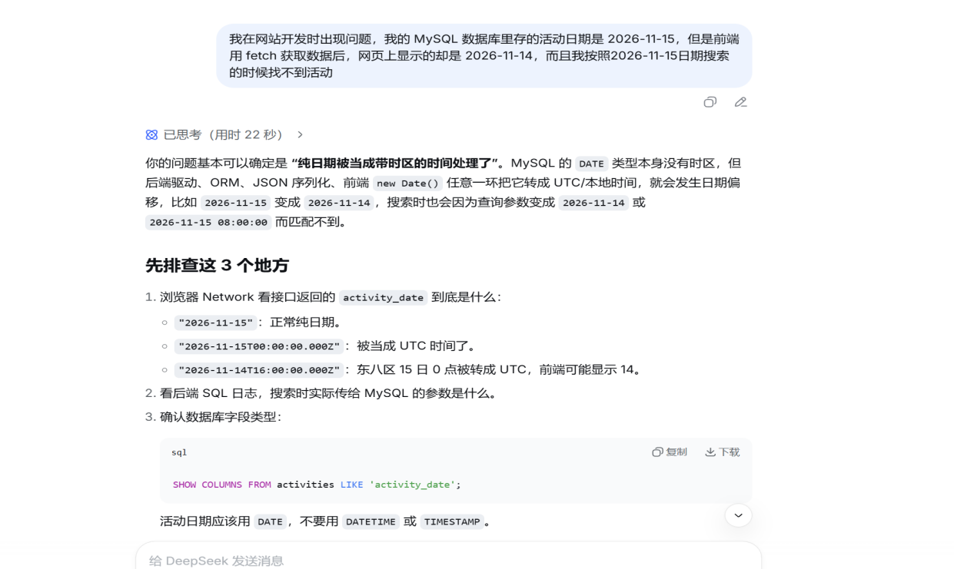

Figure 2: Verifying DATE_FORMAT fix
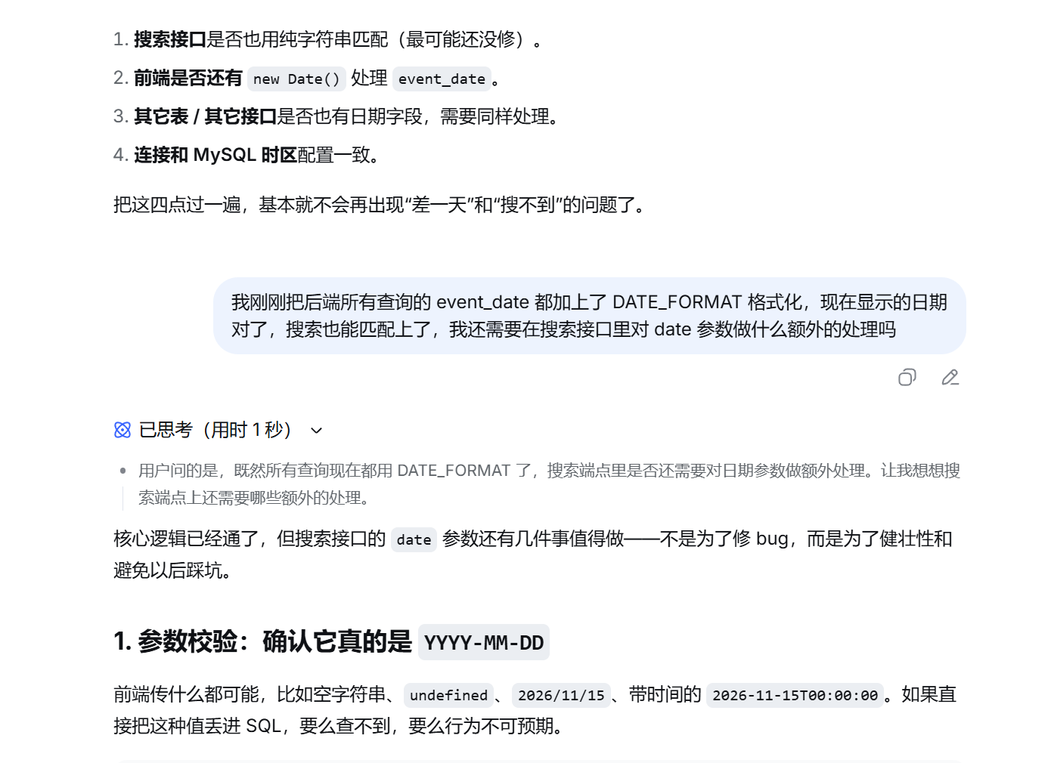

Figure 3: API parameter validation

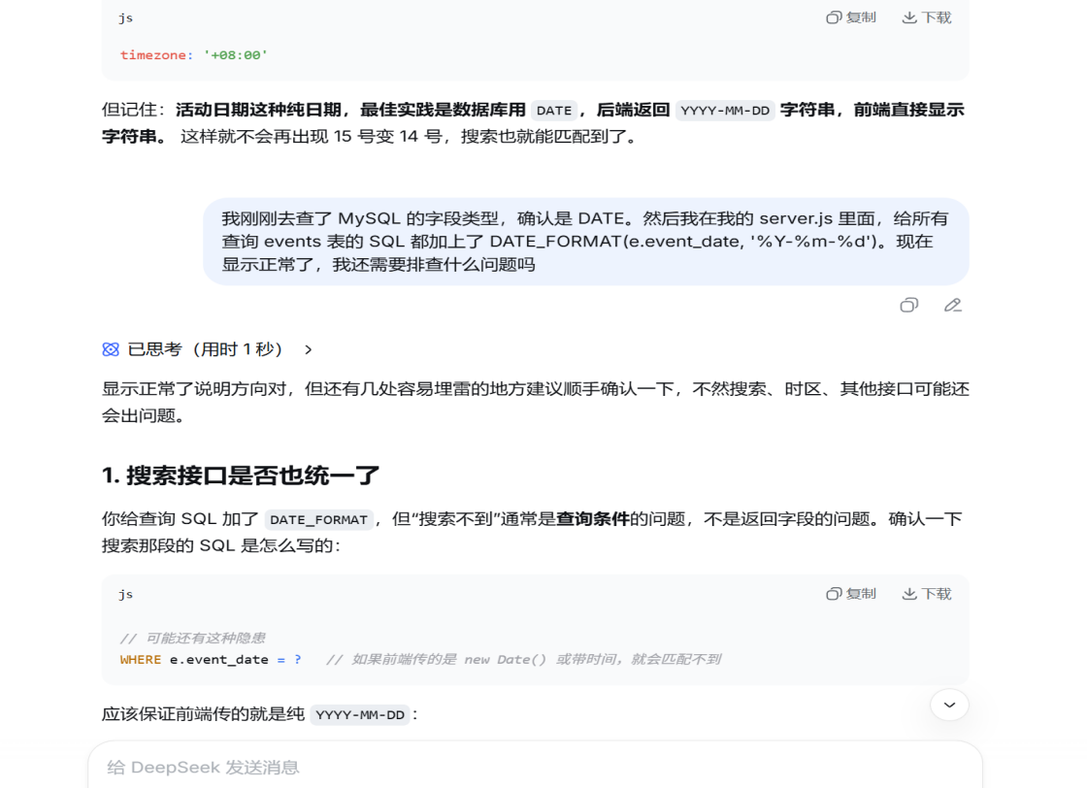

Figure 4: Fixing SQL alias error
